Obstacles Avoiding DIY Car
ASSEMBLY INSTRUCTIONS
A clear, step-by-step guide to assembling your obstacle-avoiding car.
Assembly sequence
Complete each step in order. Keep the chassis oriented as shown in the photographs, and check that all connections are secure before powering the car.
Step 1: Install the castor wheel to the wooden chassis
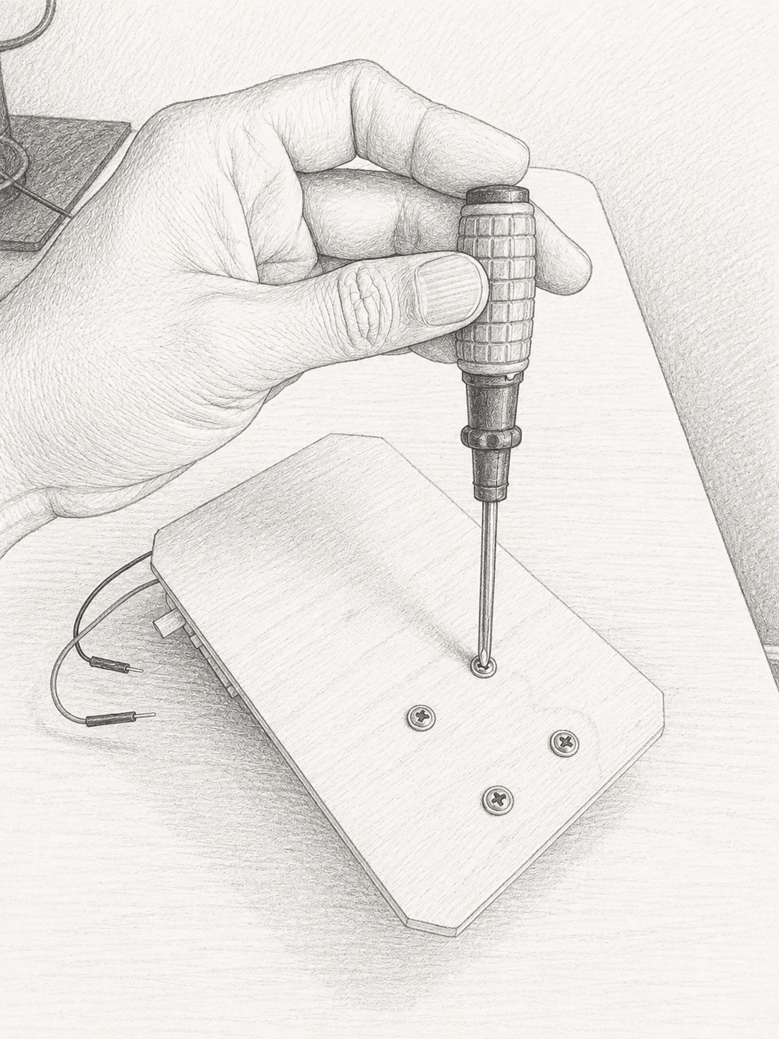
Castor wheel installation
Step 2: Install the front wheels
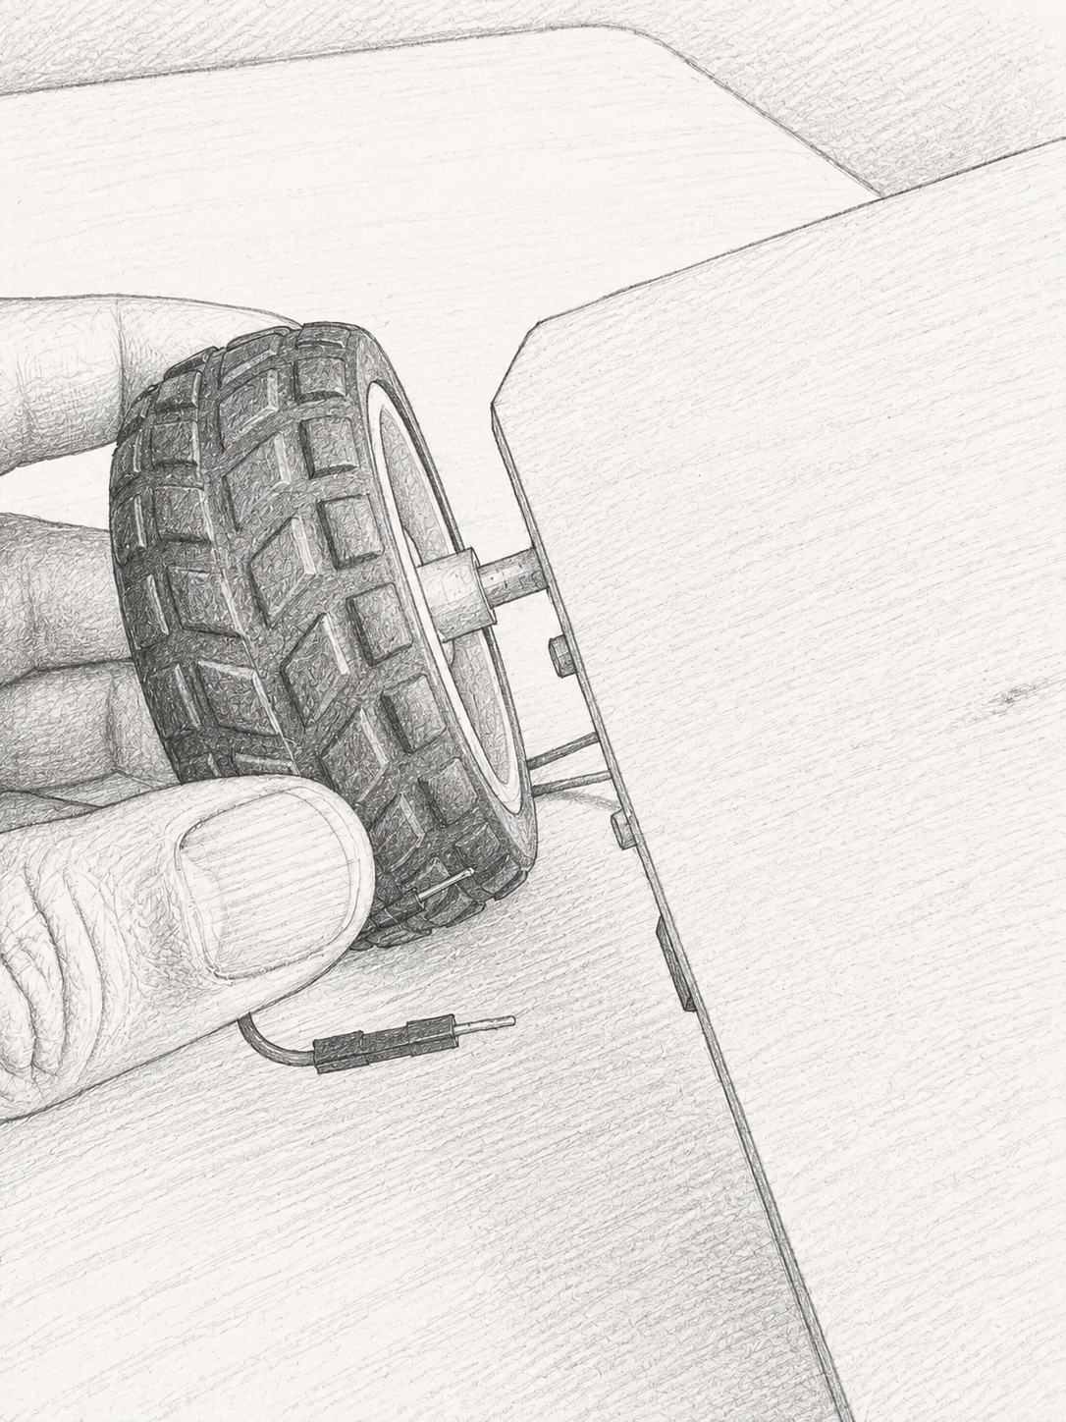  Front wheel position | 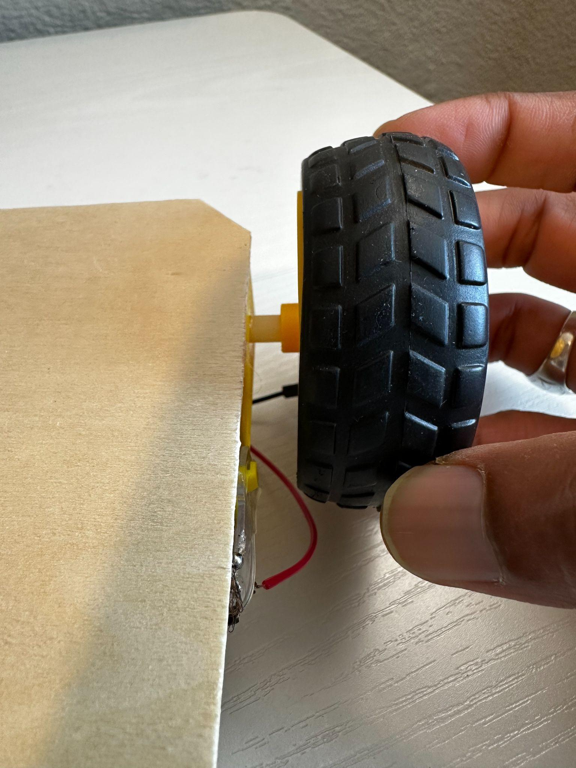  Front wheel attachment
Step 3: Mount the PCB to the wooden chassis
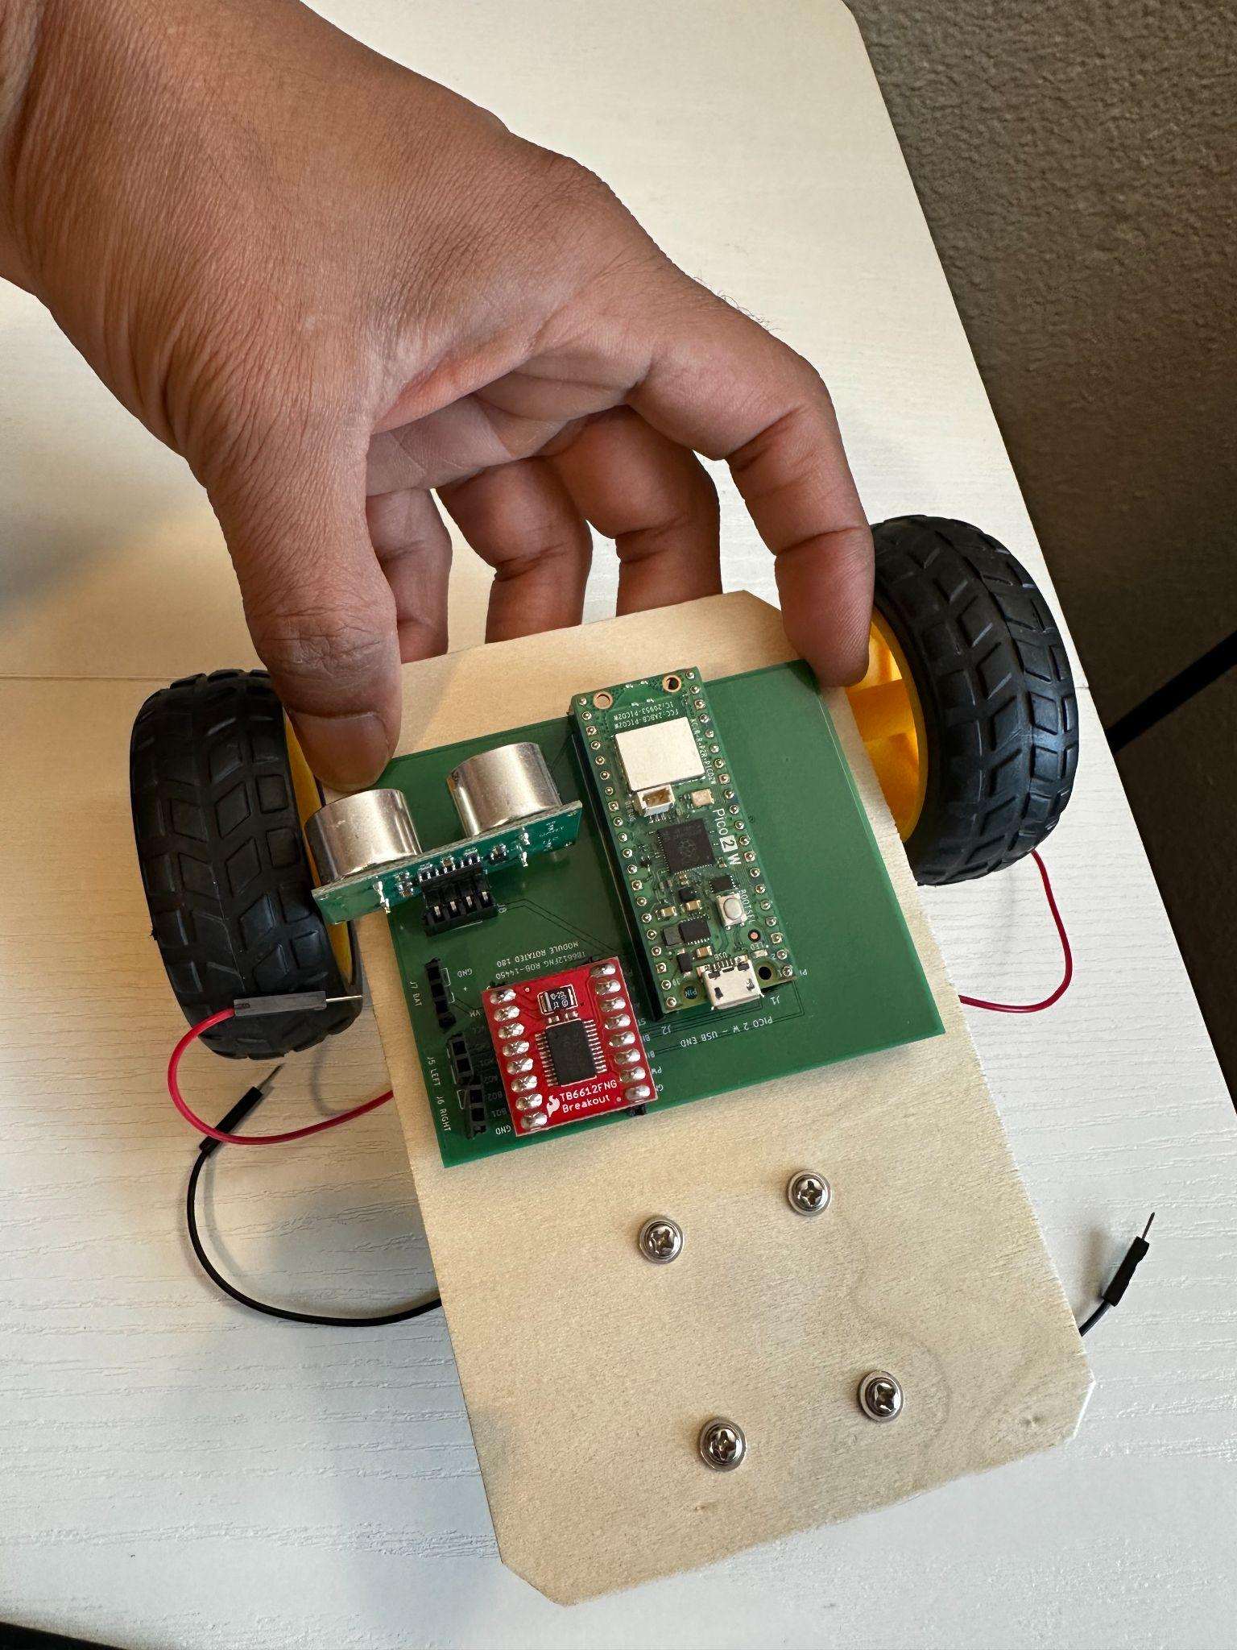
PCB mounted on the chassis
Step 4: Connect left and right motor wires
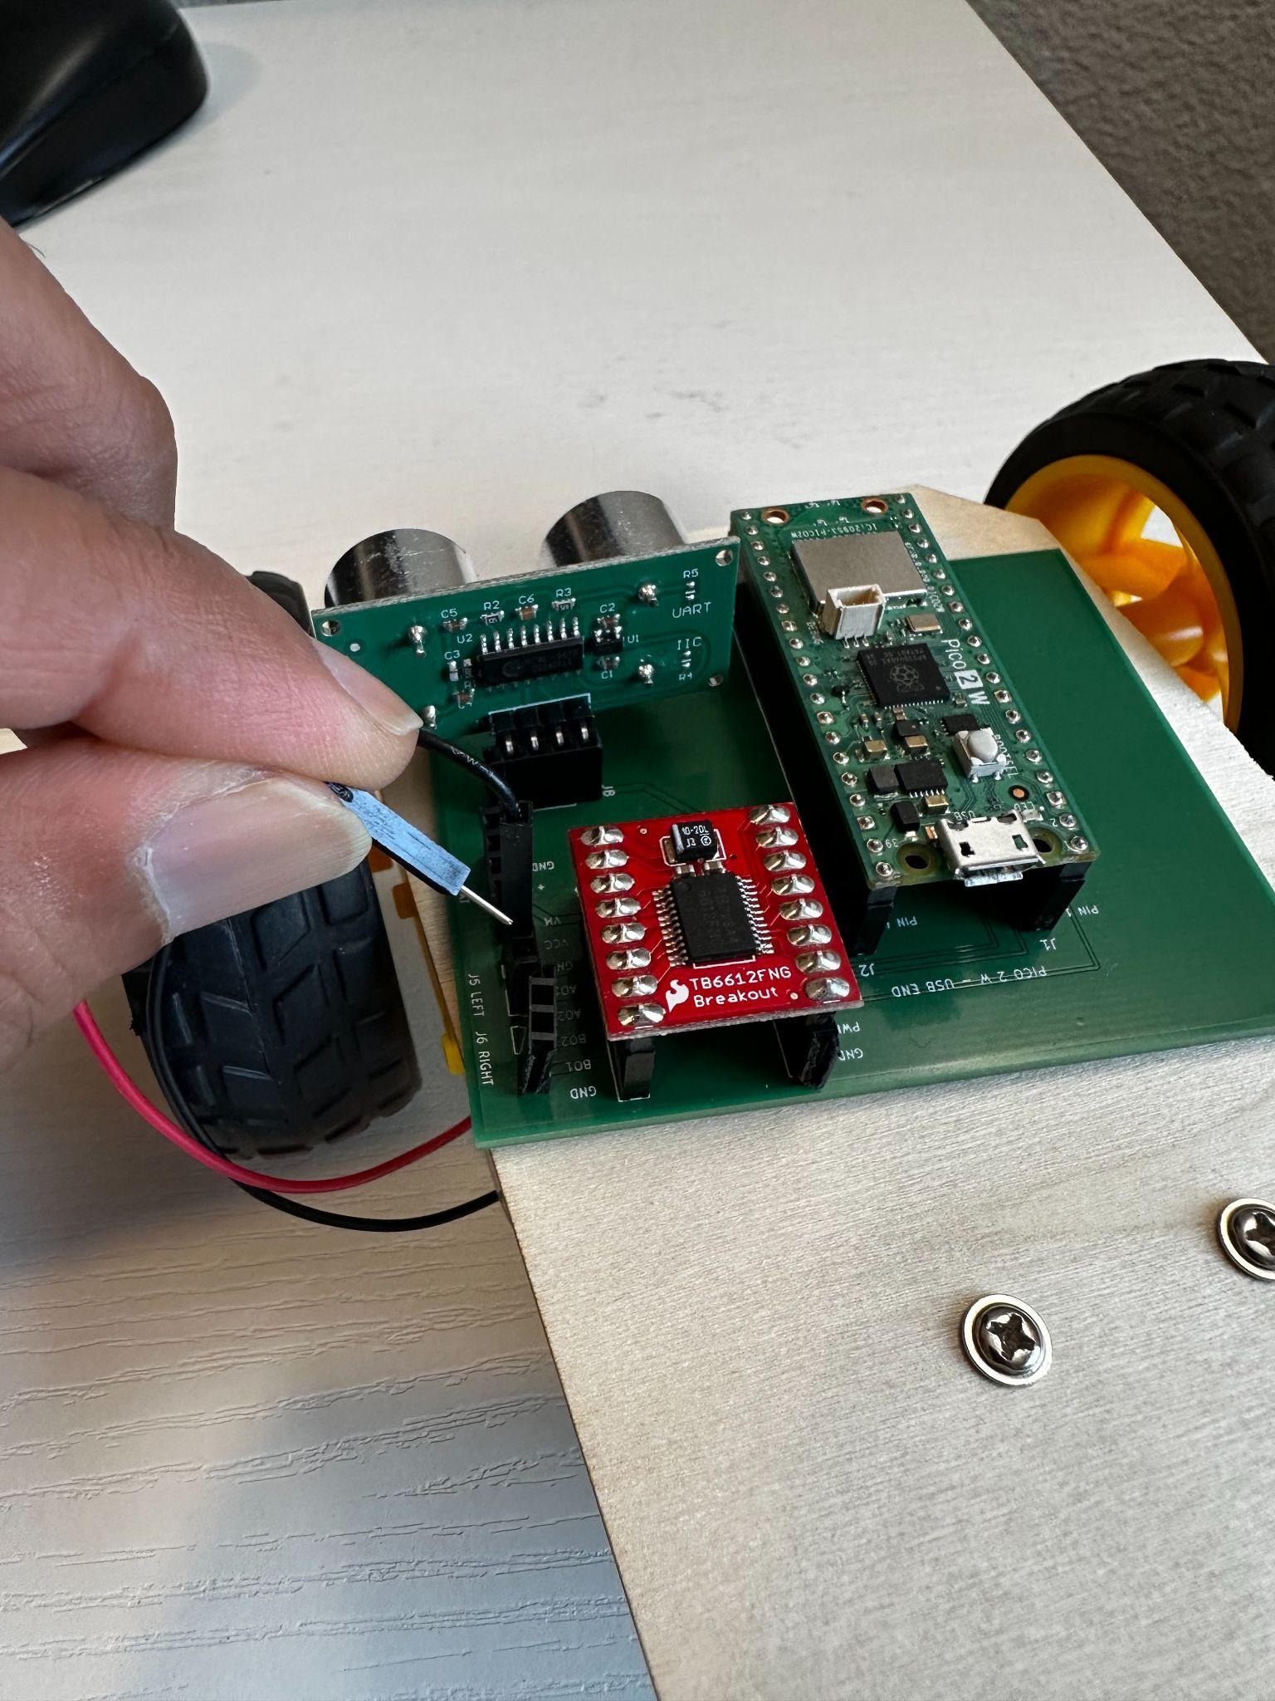  Left motor connection | 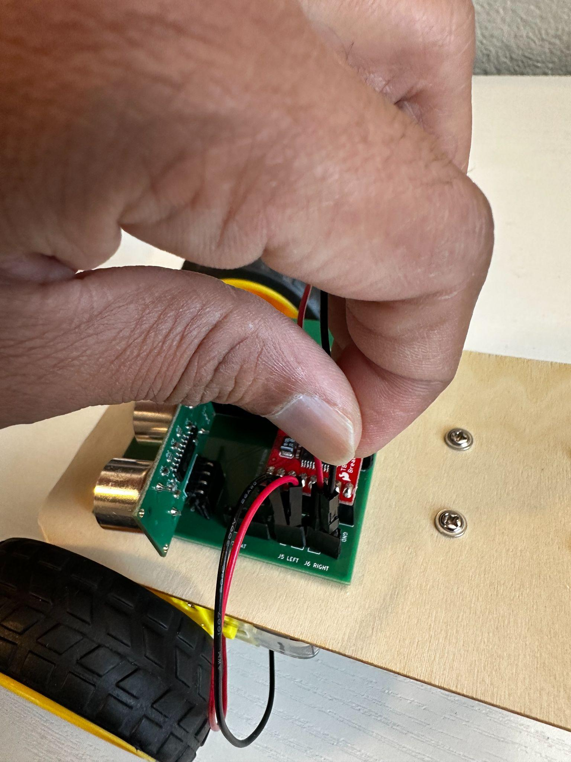  Right motor connection
Step 5: Connect batteries
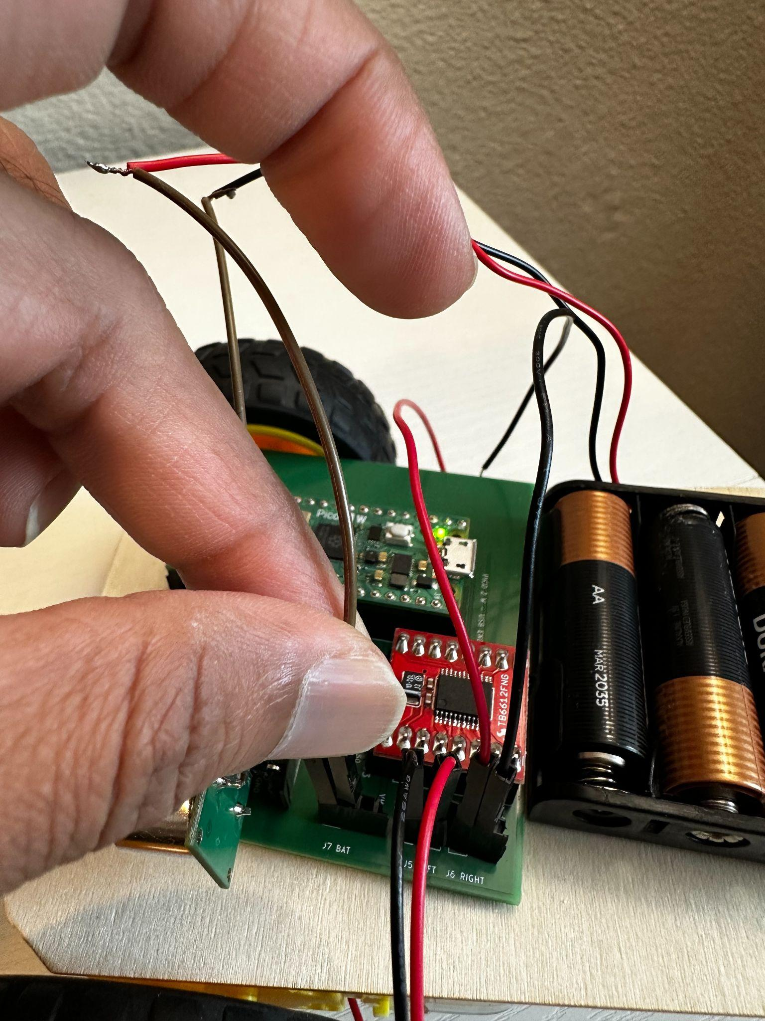
Battery connection

